**Project Design Phase-II**

**Data Flow Diagram & User Stories**

|  |  |
| --- | --- |
| Date | 27 Jun 2025 |
| Team ID | LTVIP2025TMID41259 |
| Project Name | Pattern Sense: Classifying Fabric Patterns using Deep Learning |
| Maximum Marks | 4 Marks |

**Data Flow Diagrams:**

A Data Flow Diagram (DFD) is a traditional visual representation of the information flows within a system. A neat and clear DFD can depict the right amount of the system requirement graphically. It shows how data enters and leaves the system, what changes the information, and where data is stored.



**Example:** [**(Simplified)**](https://developer.ibm.com/patterns/visualize-unstructured-text/)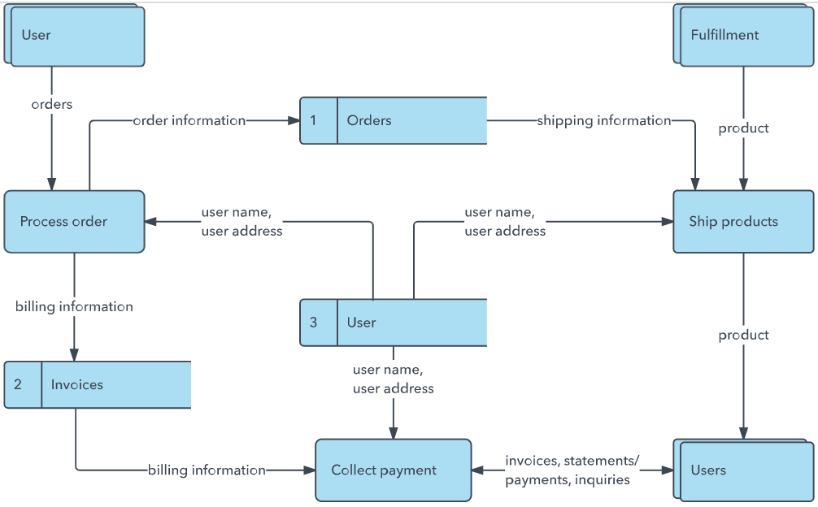

**User Stories**

Use the below template to list all the user stories for the product.

| **User Type** | **Functional Requirement (Epic)** | **User Story Number** | **User Story / Task** | **Acceptance criteria** | **Priority** | **Release** |
| --- | --- | --- | --- | --- | --- | --- |
| Farmer (Mobile user) | Image Upload | USN-1 | As a farmer, I want to upload photos of my crops so I can check for diseases. | I can upload images and get a confirmation message. | High | Sprint-1 |
| Farmer (Mobile user) | Disease Prediction | USN-2 | As a farmer, I want to receive instant feedback on possible crop diseases. | System shows predicted disease and confidence score. | High | Sprint-2 |
| System | Data Preprocessing | USN-3 | As a system, I need to resize and normalize images before passing to the model. | All images are resized and stored in standardized format. | Medium | Sprint-1 |
| Developer | Model Training | USN-4 | As a developer, I want to train a CNN model to detect various crop diseases. | Model achieves at least 80% accuracy on validation set. | Medium | Sprint-2 |
| Developer | Model Evaluation | USN-5 | As a developer, I want to evaluate model performance using precision and recall. | Metrics are documented and reviewed before deployment. | Low | Sprint-3 |
| Admin | |  | | --- | | User Management |  |  | | --- | |  | | USN-6 | As an admin, I want to manage user accounts and view system logs. | Admin can view users, edit details, and download logs | Low | Sprint-3 |
|  |  |  |  |  |  |  |
|  |  |  |  |  |  |  |
|  |  |  |  |  |  |  |
|  |  |  |  |  |  |  |
|  |  |  |  |  |  |  |
|  |  |  |  |  |  |  |